Practical-10

Aim: - program for General procedure - Selected Record's price is incremented by 500, Executing the procedure Created and displaying the update Table.

mysql> CREATE TABLE items (item_id INT PRIMARY KEY, actual_price DECIMAL (10, 2));

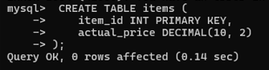

mysql> INSERT INTO items (item_id, actual_price) VALUES (101, 1500.00);

mysql> INSERT INTO items (item_id, actual_price) VALUES (102, 2500.00);

mysql> INSERT INTO items (item_id, actual_price) VALUES (103, NULL);

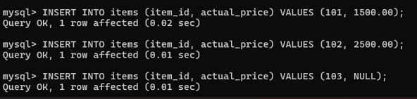

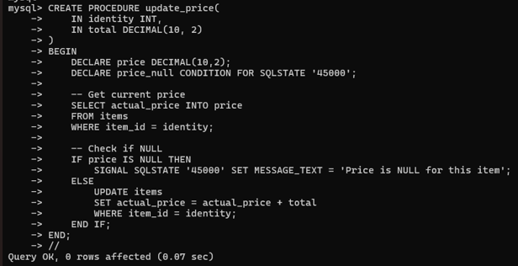

mysql> select * from items;

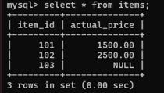

Mysql> CALL update_price(101,500.00);



mysql> select * from items;

